4.8 Denormalize data

Key points:
Before we look at denormalizing data, it's important to understand what normalized data is, where it comes from, and what is looks like:
- An important distinction to make is the difference between operational IT systems (referred to as OLTP: online transactional processing systems) and the analytical systems that we might build in Microsoft Fabric (sometimes referred to as OLAP: online analytical processing systems).

- OLTP and OLAP systems are built for different use cases, and therefore their tables are designed in different ways. OLTP systems are built for to handle lots of transactions, very fast. The backend database tables are designed to be fully 'normalized'.

- This means that entities in an OLTP application each have their own table in the backend. It might look something like this, which is an example of an entity-relationship diagram for a billing system:
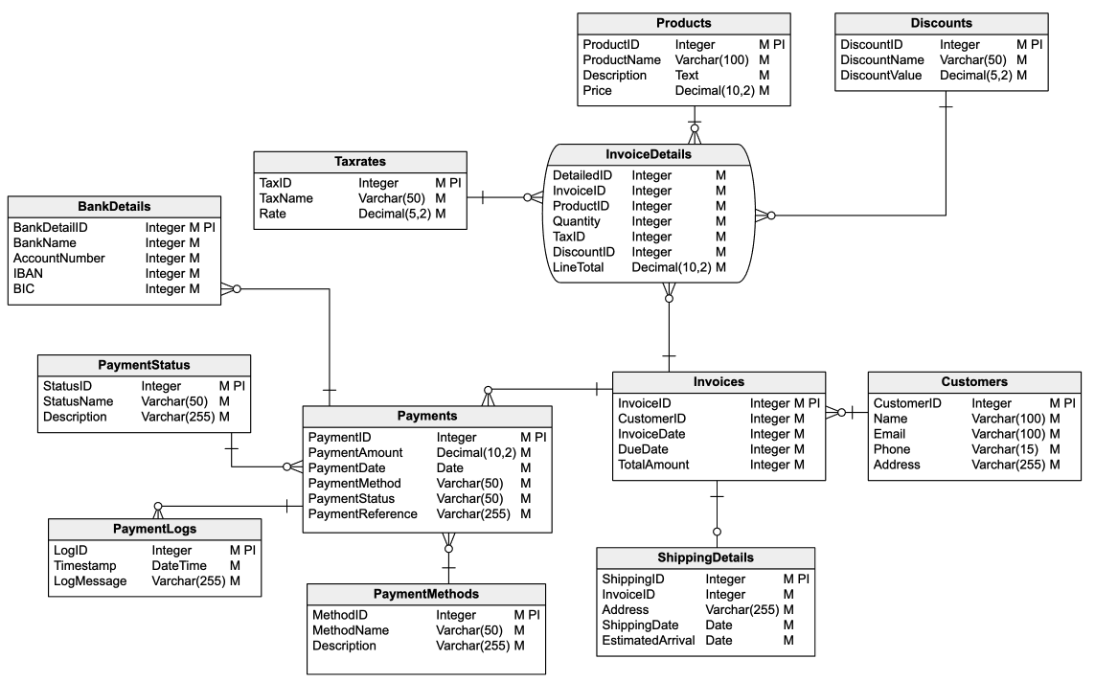
This structure minimises redundancy - every value is only stored in one place, making it efficient, from a storage perspective. But this kind of heavily normalized structure is less optimal for analytics use cases.
OLTP systems are commonly used as a data source for OLAP analytical systems, however, we must denormalize how the data is structured to make it more useful for analytical workloads.

Denormalization of data
Put simply, denormalizing data looks like this (below), two or more tables are 'denormalized' into a single table for analytics use cases. This can be done in a Data Warehouse using JOINs.
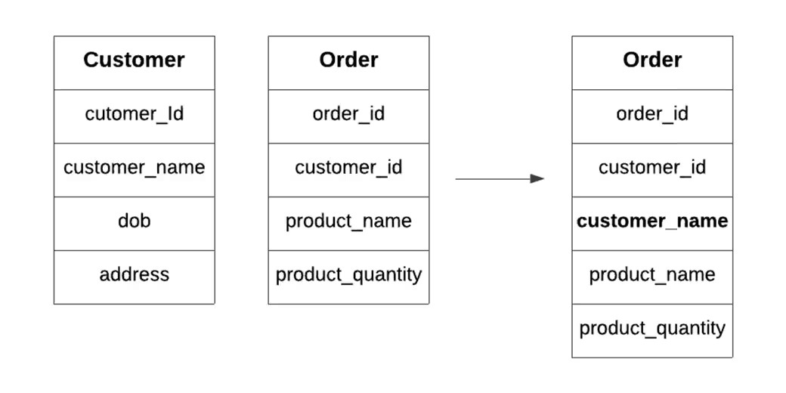

Another example from Snowflake to Star Schema:
